CS624 Full Stack Development – Mobile App
HOS04A: Building React Native App – Part II

Reviewed by Harrison Le, May 28, 2026
Reviewed by Sumit K C, August 24, 2026
Reviewed by Divakar Reddy Ravi, October 22, 2026

School of Technology & Computing (STC)
City University of Seattle (CityU)

Before You Start
- Screenshots may be different from your environment.
- The directory path shown in screenshots may be different from yours.
- There might be subtle discrepancies along with the steps. Please use your best judgment while going through this cookbook-style tutorial to complete each step.
- Some steps may not be explained in detail. If you are not sure what to do:
- Consult the resources from the course.
- If you cannot solve the problem after a few tries (usually 15 -30 minutes), ask a TA for help.

Readings and Examples
- Visit the CS624 Repository for Examples.
  - Select the related module.
  - Visit the README.md file.
  - Find examples for your practice.
- Dabit, N. (2019). React Native in Action Manning Publications. (ISBN 9781617294051)
  - Chapter 3: Building your first React Native app (The different file structure is used.)

Learning Outcomes
- Section 1: Accessing GitHub Codespaces
- Section 2: Creating a Mobile App
- Section 3: Copying the application “todos” from PE03 to Module04 HOS
- Section 4: Creating the “Heading” User Interface
- Section 5: Creating the “TodoList” Component
- Section 6: Updating the “App” Component with the “Todo” and “TodoList” components
- Section 7: Updating the “App” Component for the “Done” and “Delete” Buttons
- Section 8: Creating the “TodoButton” Component
- Section 9: Updating the “App.js” for the “TodoButton”
- Section 10: Updating the “TodoList” Component
- Section 11: Updating the “Todo” Component again
- Section 12: Testing the “App” component
- Section 13: Pushing your work to GitHub

Section 1: Accessing GitHub Codespaces

It would be best to have a GitHub account and an active internet connection to access the GitHub Codespaces environment. If you have questions about this section, please revisit section 1 in HOS01A. You will repeat the same steps for each HOS.

- Get started by creating a codespace by clicking on the "<>Code" dropdown menu in the top-right corner.
- Select "Create a codespace on main".

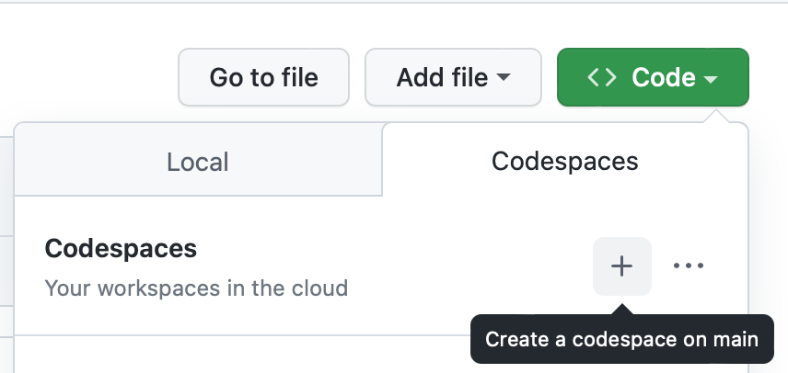
- Wait for the GitHub Codespaces environment to load. Once loaded, you can access the terminal, file explorer, and other tools to start working on your project.

Section 2: Creating a Mobile App

- Suppose you are under the current HOS directory. Run the command “npx create-expo-app hos04_todos” to create a new Expo project. Then, select a blank template for your mobile app.
- You can see a directory called “hos04_todos” created.
- Change the current directory to the newly created project using the command “cd hos04_todos.” Then install Expo and log in by running “npx expo login.”
- Run the command “npx expo start --tunnel” to start the development server.

- Scan the QR code, and you will see the screen below.
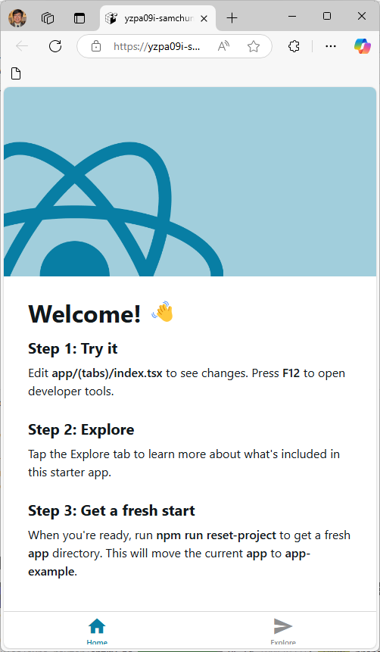

Section 3: Copying the application “todos” from PE03 to Module04 HOS

- For this exercise, you must complete part 1 of PE03. You must finish HOS03 to continue PE03.

- For copying the application “todos” from HOS03 to PE03, visit the CS624 Repository for Examples. You can find the CopyRepo guide under Module03.

- The following table shows what user interfaces will be covered in HOS04 and PE03 Part 2.

HOS or PE | User Interface | Required
HOS03A | Heading, Input
PE03 Part 1 | Button | Copy HOS03A
HOS04A | Todo List, Todo, Todo Button | Copy PE03 Part 1
PE03 Part 2 | Tab bar and Tab bar item | Copy HOS04A

- By the end of PE03 part 1, you will have the application where you are adding “todos” to the array of “todos.” The screenshots below show the screen before and after HOS04A and PE03 Part 2, respectively.

HOS04A
Before | After
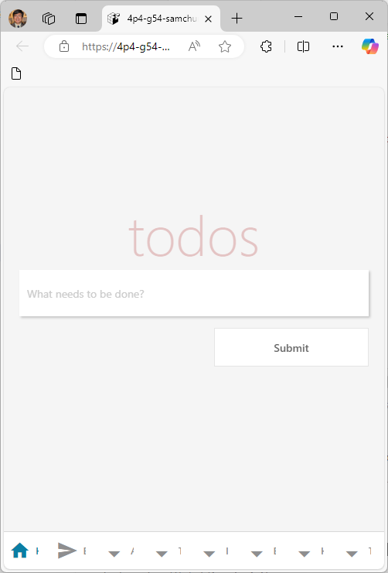 | 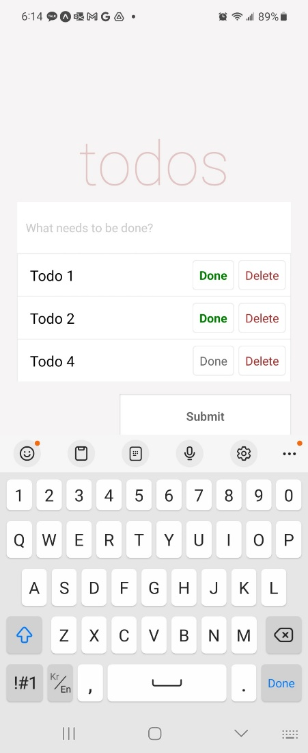

PE03 Part 2
Before | After
 | 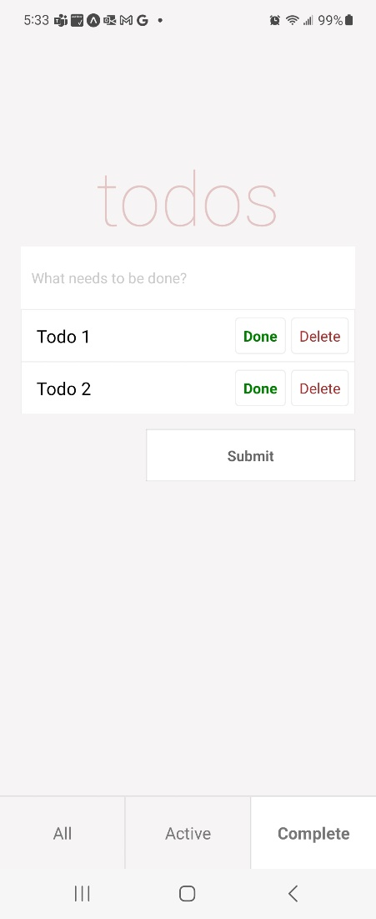

Section 4: Creating the “Heading” User Interface

- We assume that you update the “index.tsx” and invoke the App.js component. (No more will be explained for your HOS).
import App from './App';

export default function HomeScreen() {
return (
<App />
);
}

- Now, we must render them on screen. You must create the "TodoList" and "Todo" components. "TodoList" will display the list of tasks, and the "Todo" component will be used for each task. Create a file called "Todo.js." This file should be in the same directory as the "index.tsx." Update "Todo.js" with the following code.

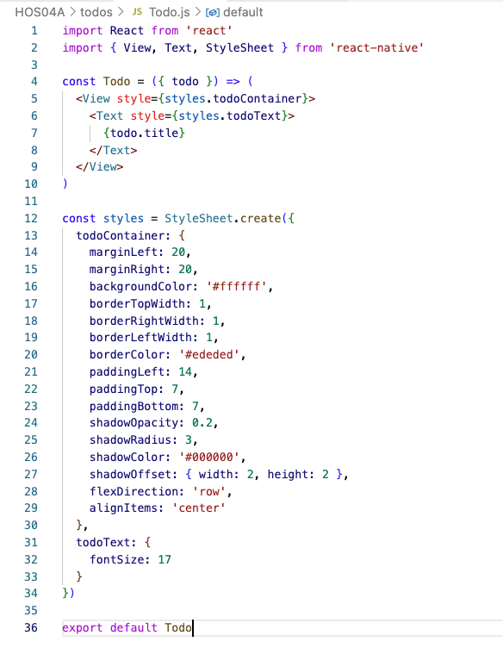

Section 5: Creating the “TodoList” Component

- Next, we need to create the “TodoList” component. Create the “TodoList.js” file. This file should be in the same directory as the “index.tsx.” Update it with the following code.

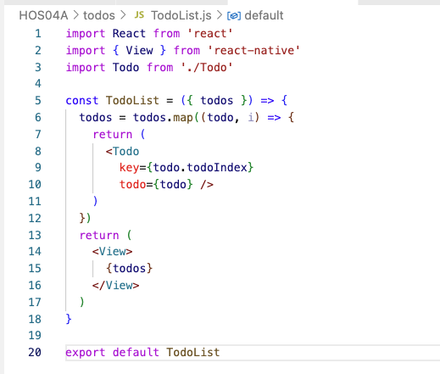

Section 6: Updating the "App" Component with the "Todo" and "TodoList" Components

- The "TodoList" component currently accepts an array of "todos" as a property. The next step is to map over these "todos," making a new "Todo" component (imported at the start of the file) for each "todo" and providing the "todo" as a property to the "Todo" component.

- Let us now import the "TodoList" component into the "App.js" file and pass in the "todos" as a property. Update the render method in "App.js," as shown below, and import the "TodoList" at the top of the file.

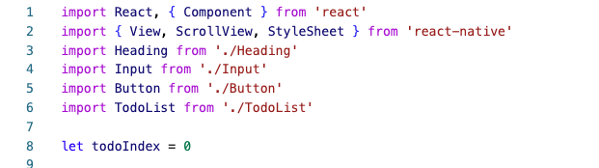

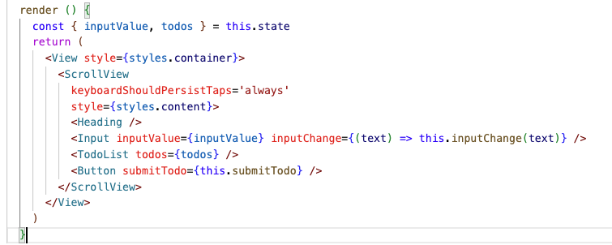

- Run the application. As you add a todo, it should appear in the list of todos, as shown in the image below. Capture a screenshot from your mobile and save it in the "todos" folder.

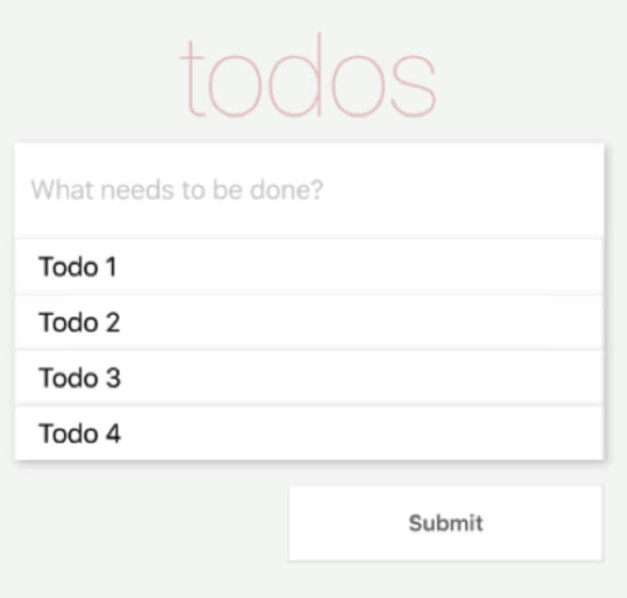

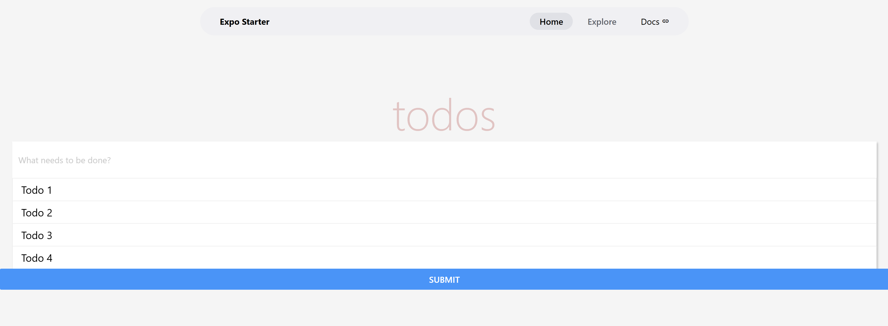

Section 7: Updating the "App" Component for the "Done" and "Delete" Buttons

- After you click " Done, " the button text should be bold and green. If you click "Delete", the "todo" item should be removed from the list of tasks. Add the "toggleComplete" and "deleteTodo" functions to App.js. First, we need to bind the functions to the class in the constructor and add them to the "App.js" file.

- Update the "App.js" as shown below.

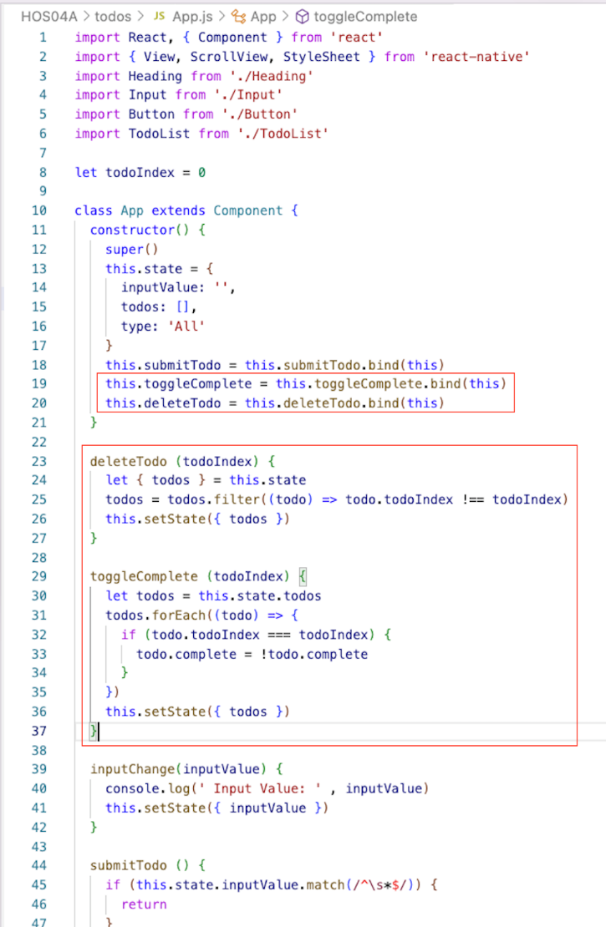

Section 8: Creating the “TodoButton” Component

- To hook up these functions, we need to create a button component to pass into the todo. Please create a new file in the same folder of “index.tsx” called “TodoButton.js” and update it with the following code.

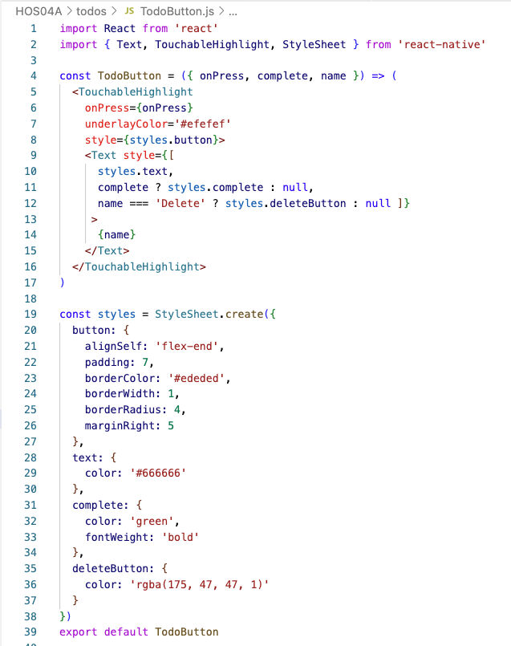

Section 9: Updating the “App.js” for the “TodoButton”

- Now we need to pass “toggleComplete” and “deleteTodo” as props to the “TodoList” from “App.js.” Update the render method in “App.js” as shown below.

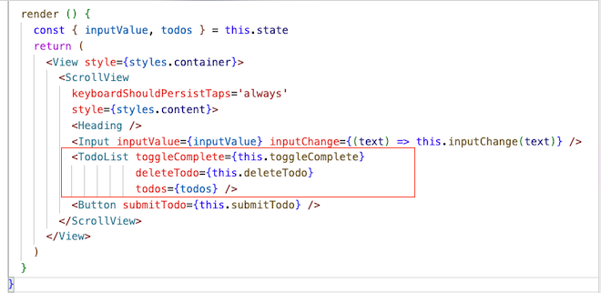

Section 10: Updating the “TodoList” Component

- We must update the “TodoList.js” and pass the “toggleComplete” and the “deleteTodo” as props to “Todo.” Update “TodoList.js” as shown below.

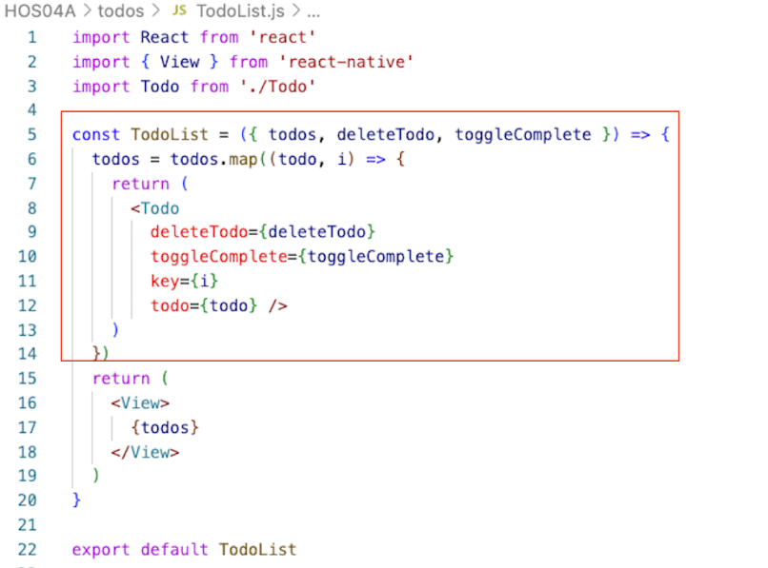

Section 11: Updating the “Todo” Component again

- To add the new “TodoButton” component and some styling for the button container, open “Todo.js” and alter the “Todo” component below.

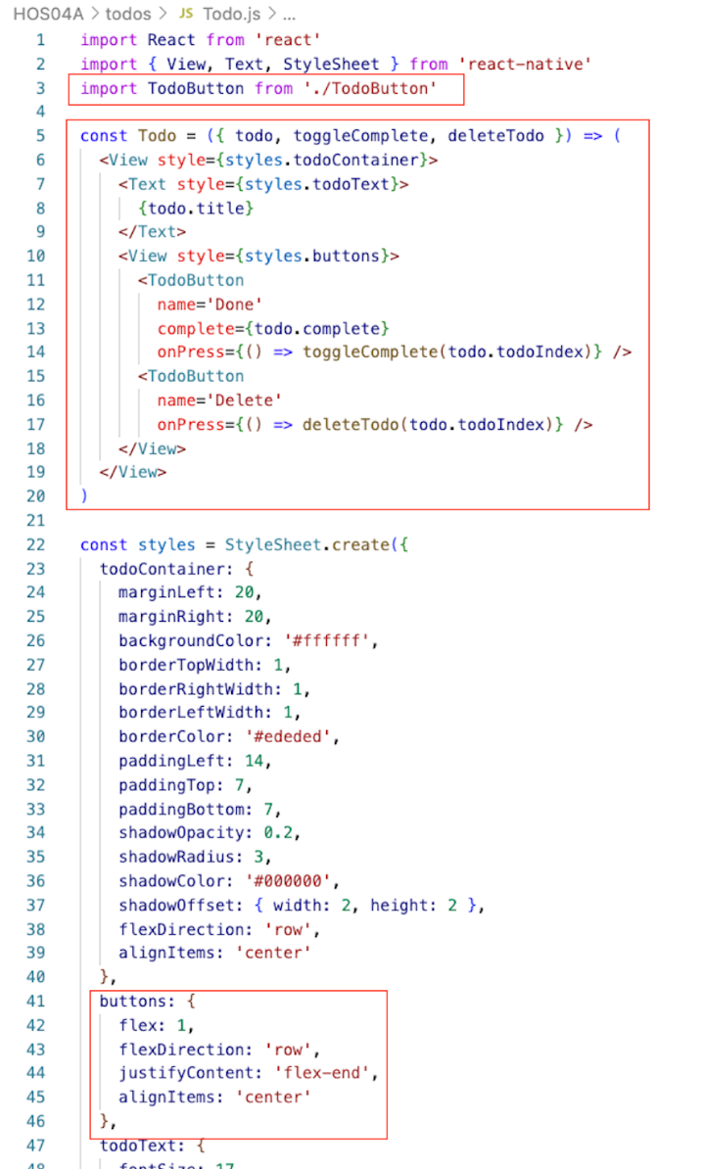
Section 12: Testing the "App" Component

- You should see the UI below if you are now testing the app. Check the app's functionality by adding tasks, completing them, and deleting a few tasks. Take a screenshot of your app UI from the mobile and save it under the "todos" folder.

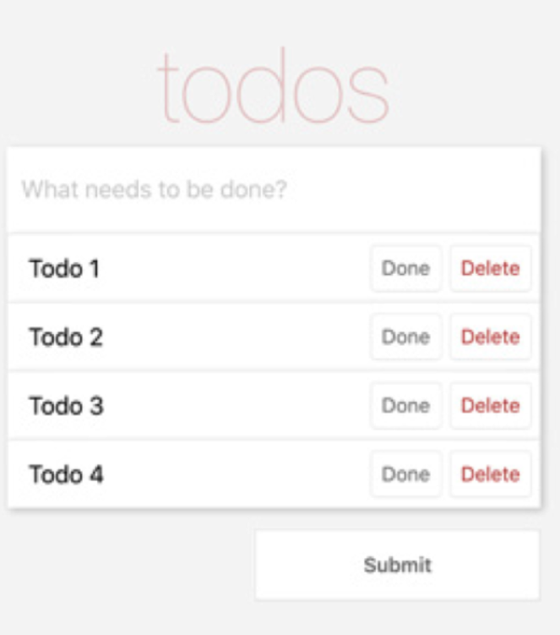
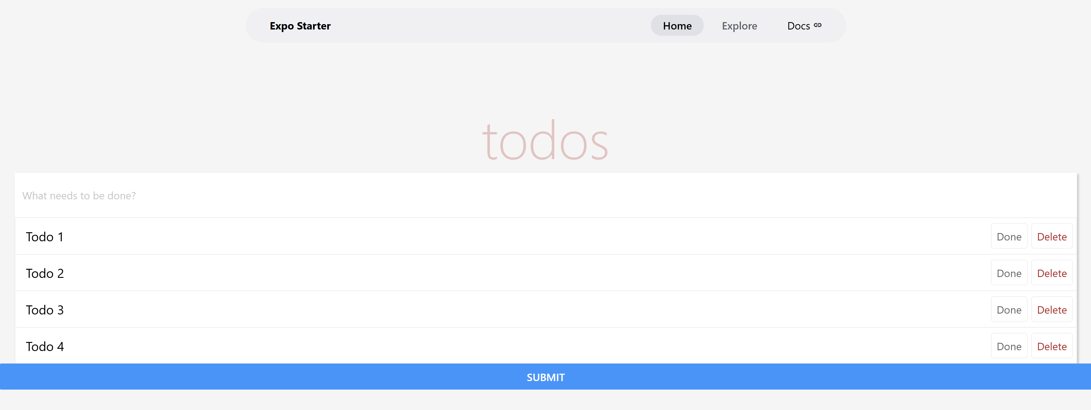

- Steps to verify the changes using the Simulator:
- Open the terminal in the GitHub Codespaces environment.
- Run the command "npx expo start –tunnel" to start the expo development server.
- Wait for the development server to load and show the QR code.
- Open the "Expo Go" app from your mobile device.
- Scan the QR code shown in the terminal with the "Expo Go" or Camera (iOS) app.
- Wait for the app to load on the mobile device.
- If you are connected and want to reload, press "r" in the terminal.

Section 13: Pushing your work to GitHub

  - Go to Source Control on your GitHub Codespaces and observe the pending changes.

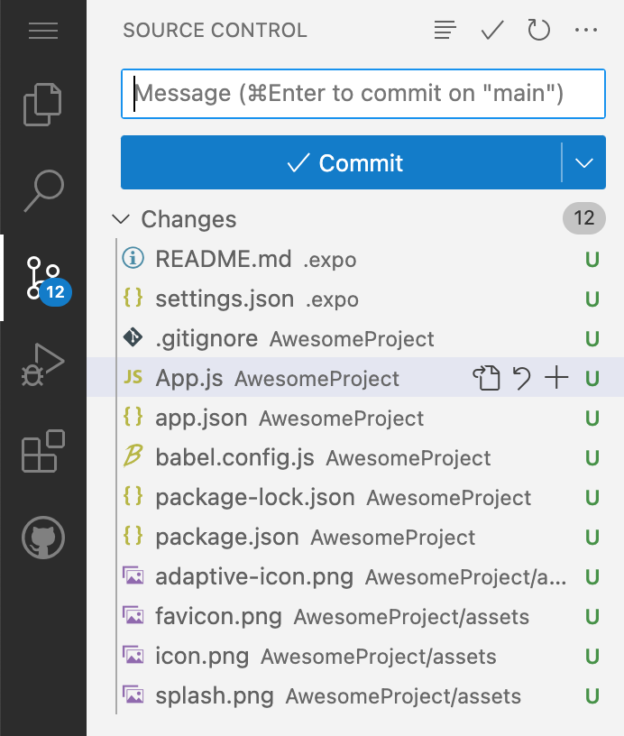

  - Type the Message for your changes to the Message box on the top. Example, “Submission for Module04 – Your Name”

  - Click on the dropdown beside the commit button and select Commit & Push to update the changes to your repository main branch.

  - Select Yes when prompted.



